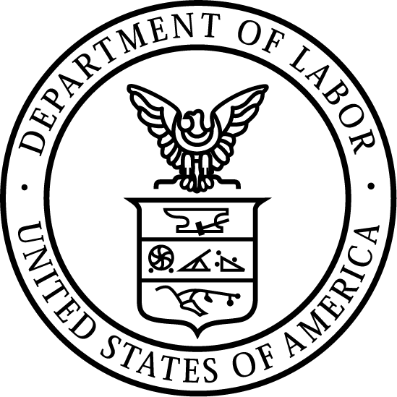
News Release
U.S. Department of Labor | April 13, 2020

U.S. Department of Labor Announces OSHA Interim
Enforcement Response Plan to Protect Workers during the Coronavirus Pandemic

WASHINGTON, DC – The U.S. Department of Labor’s Occupational Safety and Health Administration (OSHA) today announced an interim enforcement response plan for the coronavirus pandemic. The response plan provides instructions and guidance to OSHA Area Offices and compliance safety and health officers (CSHOs) for handling coronavirus-related complaints, referrals, and severe illness reports.

During the coronavirus outbreak, OSHA Area Offices will utilize their inspection resources to fulfill mission essential functions and protect workers exposed to the disease. The response plan contains interim procedures that allow flexibility and discretion for field offices to maximize OSHA’s impact in securing safe workplaces in this evolving environment.

“OSHA is committed to protecting the health and safety of America’s workers during this challenging time in our nation’s history,” Principal Deputy Assistant Secretary Loren Sweatt said. “Today’s guidance outlines commonsense procedures for investigating complaints related to the coronavirus, while also ensuring the safety of workers, employers, and inspectors.”

The response plan outlines procedures for addressing reports of workplace hazards related to the coronavirus. Fatalities and imminent danger exposures related to the coronavirus will be prioritized for on-site inspections. The response plan contains procedures and sample documentation for CSHOs to use during coronavirus-related inspections. Workers requesting inspections, complaining of coronavirus exposure, or reporting illnesses may be protected under one or more whistleblower statutes and will be informed of their protections from retaliation.

This memorandum will take effect immediately and remain in effect until further notice. It is intended to be time-limited to the current public health crisis. Check OSHA’s webpage at www.osha.gov/coronavirus frequently for updates.

Under the Occupational Safety and Health Act of 1970, employers are responsible for providing safe and healthful workplaces for their employees. OSHA’s role is to help ensure these conditions for America’s working men and women by setting and enforcing standards, and providing training, education and assistance. For more information, visit www.osha.gov.

The mission of the Department of Labor is to foster, promote, and develop the welfare of the wage earners, job seekers, and retirees of the United States; improve working conditions; advance opportunities for profitable employment; and assure work-related benefits and rights.
# # #

Media Contact:

Emily Weeks, 202-693-4681, weeks.emily.c@dol.gov
Release Number: 20-631-NAT

